GVSU Marching Band Database

Ron Foreman, Rob Sanchez, Victor Sun, Justin Wickenheiser

CIS 673 - 01
Fall 2017

Table of Contents

Requirements Specification 3

Enhanced Entity-Relationship (EER) Diagram 5

Relational Schema (BCNF) 6

Integrity Constraints Table 7

Requirements Specification

Nature of the Application
The following database design is intended to support an application for creating and managing marching shows in multiple seasons, to be performed by Grand Valley State University’s Laker Marching Band. The application will be used to maintain the detailed plan for each Show, including each student’s involvement in different shows throughout the seasons along with specific Songs, uniforms and instruments.

Student
The system tracks Students that are in the school marching band. Students have a unique student id, in addition to name and academic major attributes. Every Student in the system is either a Marcher or a Drum Major.

Season
The system tracks the different marching Seasons. Seasons have a unique term code as well as a description. Each Season is composed of Shows.

Show
The system will track marching Shows. Shows have a title and a performance date. A Show belongs to a specific Season and a Season can be composed of many shows.

Song
The system will also track Songs. Songs have a unique Song ID, a title, tempo, measure count, and one or more composers. For any given Show in a given Season, there are Songs that make up the Show. A Show can have many Songs and a Song can be in multiple Shows. A Show must have at least 1 Song in it, but not every Song has to be in a Show. The system must also track the order of the Songs in each Show. The system will only track Songs that have a minimum tempo of 96 beats per minute and a minimum of 50 measures.

Marcher
Marchers participate in Shows. Since some Marchers might be busy or otherwise unavailable during a Show, not every Marcher participates in a given Show. Additionally, there can be Shows that are planned for future Seasons, so not every Show has Marchers participating in it. A Marcher can participate in several Shows, and a Show has one or more Marchers. The system needs to track what instrument a Marcher plays for a given Show. A Marcher will only play one instrument per Show. The instrument that a Marcher can play must be one of the following: Piccolo, Clarinet, Alto Sax, Tenor Sax, Mellophone, Trumpet, Trombone, Baritone, Sousaphone, Percussion, Flag, or Twirler. A Marcher must play the same instrument for every Show they participate in for a given Season.

Lead Conductor
Drum Majors “become” Lead Conductors for specific Songs of any given show. “Lead Conducting” is an event that occurs during a show, and the duration of that event could be one or many Songs. “Lead Conductor” is a role a Drum Major takes on for the duration of a Song or Songs during a Show. A Song only has one Lead Conductor per Show. Not every Drum Major has to be a Lead Conductor within a Show. Every Song within a Show must have a Lead Conductor; however, since Shows can be planned for future Seasons, not every Show will have Lead Conductors assigned to Songs.

Uniform
The system will track the Uniforms that are assigned to Students. Uniforms are uniquely identified by their uniform ID, and the system will track the date on which each Uniform was purchased. Each Student checks out only one Uniform, and a Uniform can only be checked out by one Student. Not every Uniform in the band's inventory is necessarily checked out.
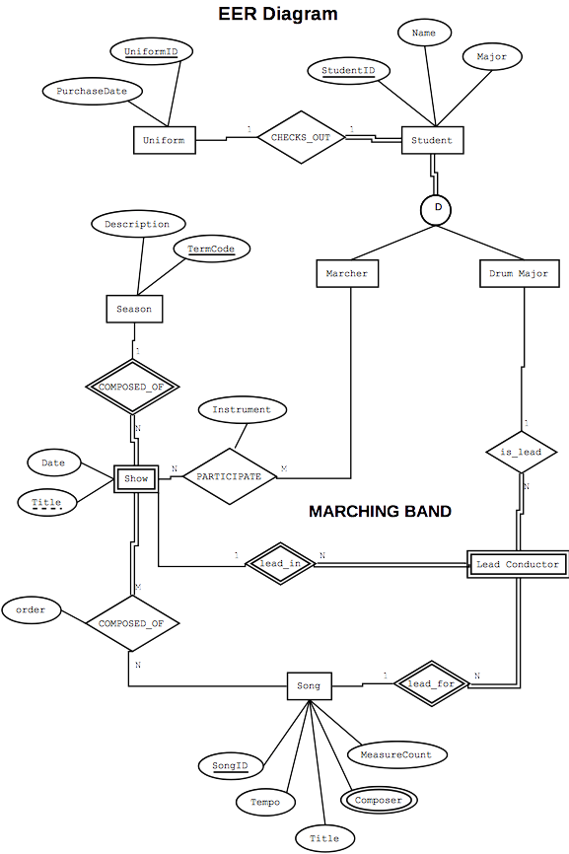

Relational Schema (Boyce-Codd Normal Form)

Design Choice
Marcher and DrumMajor are subtypes of entity Student. We chose design alternative #2 from the EER.ppt lecture notes and created one table per subtype, with no supertype table. At the beginning of the design process, we wanted to avoid the need for joins on queries requiring subtype attributes, but ultimately we didn’t create such queries anyway. Since our sub-typing was not overlapping but disjoint instead, it turned out to be a satisfactory decision.

Marcher(StudentID, FirstName, LastName, Major, UniformID)
DrumMajor(StudentID, FirstName, LastName, Major, UniformID)
Uniform(UniformID, PurchaseDate)
Season(TermCode, Description)
Show(TermCode, ShowTitle, Date)
Song(SongID, Title, Tempo, MeasureCount)
Composer(SongID, Composer)
Participation(MarcherID, TermCode, ShowTitle, Instrument)
LeadConductor(TermCode, ShowTitle, SongID, drumMajorID)
ShowLineup(TermCode, ShowTitle, SongID, Order)

Integrity Constraints Table

IC Name & Tables | IC Type | English Statement | Page  Found | Page Tested
marcher_IC1  table: Marcher | Key | Marchers have a unique student ID | Page A1  Line 36 | Page A16  Line 956
composer_IC2  table: Composer | Foreign Key | The Song ID must be an existing Song; if a Song gets deleted, delete the composer for that Song also. | Page A2  Line 128 | Page A16  Line 990
participation_IC3  table: Participation | 1-attribute | The instrument that a Marcher can play must be one of the following: Piccolo, Clarinet, Alto Sax, Tenor Sax, Mellophone, Trumpet, Trombone, Baritone, Sousaphone, Percussion, Flag, or Twirler. | Page A3  Line 156 | Page A16  Line 1005
song_IC2  table: Song | 2-attribute, 1-row | If the Song has 200 or more measures then the tempo must be greater than or equal to 120. | Page A2  Line 111 | Page A17  Line 1026
participation_IC5_tr  table: Participation | 2-row (trigger) | A Marcher must play the same instrument for every Show they participate in for a given Season. | Page A4  Line 200 | Page A17  Line 1039

